5. Identifying and overcoming challenges

Introduction
All over the world there has been a deliberate effort put in place to ensure integration of technology in teaching and learning. However, in a developing nation like Nigeria, integration of technology in teaching and learning has generated a lot of challenges to the teachers and the teacher educators. In spite of the challenges associated with the development and use of educational technology/ materials, the push to provide technology in schools has been increasingly successful in recent years. For example within the teachers’ training colleges, most schools now have computer labs with many teachers owning personal laptops; while some have multimedia projectors for classroom presentation of lectures. Research has shown that more than 90 percent of all teachers’ training schools in Nigeria are connected to the Internet. Yet teacher educators admit that they are not making much use of technology in their lesson delivery. What then are the challenges of teacher-educators? As a teacher-educator, do you have adequate knowledge and skills required to selection, design and use technology for your lectures? Do you have technology coordinator in your college? Do the technology coordinators in your college readily assist you in using technology in your class? Are there electricity and standby generators to support use of technology in your college? To what extent do your students use computers and what programmes are they acquainted with in learning? Have you been engaged in software development for the teaching of any course? These are the kinds of questions we explore in this unit.
This unit will probably take about 6 hours to complete.

5.1 Unit outcomes

Upon completion of the unit, you will be better able to:
Outcomes | - Identify the challenges associated with the use of classroom technology  - Demonstrate the use of higher education technology material.  - Explain the benefit of multimedia inclusion in technology-based instruction.  - Discuss the challenges associated with the use of distance learning technology and possible solutions.  - Identify the technology guiding principles in instructional design.

5.2 Challenges associated with the use of classroom technology

Activity 5a | Purpose  This activity will help you to begin to identify challenges observed from the use of classroom technology.  Time  This activity will take about 45 minutes.  Read the discussion at the link below:  http://www.teachhub.com/12-easy-ways-use-technology-your-classroom-even-technophobic-teachers  - What should the teachers at novice or apprentice stages of technology do in choosing appropriate software?  - What are the goals of technology in schools?  - What are the action options of the teachers in using technology?

Discussion
Compare the following ideas with your own.
Most teachers have heard horror stories about equipment failure, software complexity, data loss, embarrassments, and frustration. They don't want to be left hanging with 30 students wondering why nothing is working the way it is supposed to be. When teachers are trying to use technology in their classrooms and they encounter difficulties, they need the immediate help a technology coordinator can render. Technology integration is essential in bringing changes to teachers' instructional roles in the classroom. The teacher's roles in a technology-infused classroom often shift to that of a facilitator or coach rather than a lecturer. Technology use also tends to foster collaboration among students. Instead of focusing on isolated, skills-based uses of technology, schools should promote the use of various technologies for sophisticated problem-solving and information-retrieving purposes. One barrier to technology integration is the difficulty many teachers face in finding and using appropriate software for instruction. Teachers at novice or apprenticeship stages of technology integration may need guidance in locating multimedia software and Internet sites to support their lectures, either because they are unfamiliar with these media or because they feel overwhelmed by the profusion of software on the market and sites on the Internet. Therefore, when software-selection activities are needed, it should involve teams of teachers. Teachers working together can plan curricular projects, develop and apply criteria for selecting software or Internet sites, engage in action research) to evaluate the use of specific software or Internet sites, and reflect upon how their teaching is changing through technology integration. Teaming can facilitate technology integration, especially when teacher teams reflect on their degree of success.
Teachers:
- Should be or get familiar with Educational technology equipment and are accessible for use in the colleges. Determine how students get involved in technology usage in the classroom. Become aware of the impact of collaborative learning among students.
- Develop an individual professional development plan that provides for acquisition of technology skills and integration of technology into classroom projects.

5.3 Challenges associated with use of higher education technology materials
In this section we will explore some of the challenges associated with higher education technology materials.
Activity 5b | Purpose  This activity will help you to think about a range of changes that you, as an education professional, need to equip yourself to address  Time  This activity will take about 45 minutes.  Read the following extract and answer the questions below: Using multimedia in classroom presentation  http://www.britishcouncil.in/sites/britishcouncil.in2/files/day_2_-_soni_joseph.ppt  http://www.nou.edu.ng/uploads/NOUN_OCL/pdf/EDU/EDT%20828%20MULTIMEDIA%20TECHNOLOGY%20IN%20TEACHING%20AND%20LEARNING.pdf  Write answers to the questions in your workbook.  - State five challenges of multimedia production in the text and identify others not mentioned in the text and discuss the solution in your online group discussion.  - State the rationale for the use of multimedia presentation in your classroom.  - Itemize five environments that could serve as a platform for hypermedia.  - When using multimedia in your class, what should be key steps in the teacher-educators’ action plan?

Discussion

Discussion
Again there are many possible responses to the issues raised above and it would be worthwhile comparing ideas with colleagues.
Multimedia is new in teaching and learning processes and has been interpreted by different people in different ways to mean different things. Some people see multimedia as just computer based instruction. It goes beyond this. The name ‘multi’ in multimedia means ‘many’, this implies that many media are put together to form a single medium of instruction which may be facilitated through the use of the computer. The computer acts as the compiler. Another definition that could be used is ‘integration’ of different media to form a single medium’.

Benefits of multimedia are the following:
- Gives opportunity for whole class delivery of information.
- Allows equality access of information.
- Enables the use of multimedia files to enhance understanding of ideas and concepts such as text, pictures, animations, graphs, sound and video files
- Supports a high level of interactive lesson with supportive lesson materials.
- Enhances the delivery of differentiated learning opportunities through the extended activities.
From researches and observations it has been discovered that most educational multimedia courseware are faced with the following problems – poor scripting, lack of proper documentation, lack of clear roles and responsibilities, inappropriate feasibility studies and lack of quality control. Some others are true constraints arise from ambiguity, uncertainty and sometimes lack of criteria for knowing the limits of mediocrity and the excellence of success. To alleviate these problems the following solutions were proffered to have a good plan of project life cycle, analysis of requirements, design specification, and consider a good delivery mode and good resource production.
Teacher Educators should have the following plan action when intending to use multimedia;
- Prepare a class plan
- Develop the plan as a slideware presentation
- Build in some flexibility
- Fight against the “mind-numbing” property of slideware.
Hypermedia refers to multimedia systems that include nonlinear structure of information units, events, and discrete media. Hypermedia can be considered as one of the multimedia applications which combined materials in many media—text, graphic art, sound, video and animation; are delivered via digital computer or other electronic means, and provides a linked structure through which a user can navigate through element. Hypermedia may be developed in a number of ways e.g. programming tool can be used to write programs that link data from internal variables and nodes for external data files. Multimedia development software such as Adobe Flash, Adobe Directors can as well be used to develop hypermedia. Hypermedia applications may be developed on embedded devices for the mobile and the Digital signage industries using the Scalable Vector Graphics (SVG) specification from W3C (World Wide Web Consortium).

5.4 Challenges associated with the use of distance learning technology
Countries all over the world are battling with a rising tension between the need for expanded higher education in a global knowledge economy but rising costs that militate against building new campuses and hiring new academic staff. An increasing number of countries are exploring the use of open and distance learning (ODL) approaches. Unisa, the largest university in Africa with close to 400 000 enrolled students is an ODL institution. Others include the Zimbabwe Open University and the Open University of Tanzania. Recently, Ghana, Kenya and Mozambique all expressed intentions to launch new open universities using a combination of Open, Distance and eLearning (ODeL). ODL and ODeL are most extensively used to offer teacher education and hence we include a discussion of this in this sub-section.
Activity 5c | Purpose  This activity will help you to reflect upon your own teaching career with a view to gaining a better understanding also of the motivations of others.  Time  This activity will take about 40 minutes.  Read the extract: Science of E- Learning developed by Richard Mayer at:  http://cecs5580.pbworks.com/f/elements+of+a+science+of+e-learning.pdf  and Distance Education technology and media utilization in higher education at:  http://www.itdl.org/Journal/Aug_10/article01.htm  Then answer the questions below in your workbook.  - Discuss what prevailing principles teacher-educators should consider while designing instruction for electronic-based distance learning.  - What are the relative differences between uses of teleconferencing, online forum, Cd Rom etc?  - Discuss technology guiding principles from the test and highlight some additional challenges that you may have observed.

Discussion

Discussion
As usual there are many possible responses to the issues raised above and it would be worthwhile comparing ideas with colleagues.
E-learning as training delivered on a computer (including CD-ROM, Internet, or intranet) that is designed to support individual learning or organizational performance goals. Synchronous forms of e-learning, also called virtual classrooms, have assumed a large and growing share of online training courseware in the recent time. In designing courseware for use a number of issues are considered. Medium of delivery of already designed instruction, students’ accessibility, what principles should be involved or considered in the design and the choice of the technology to be used. What kind of skills is needed as you engage your students through synchronous or asynchronous online forums etc.?
Electronic learning is effective because of accessibility anywhere and at learners pace thus some principles must have to observed and accurately applied to ensure the effectiveness of such instruction. The principle includes:

- Applying multimedia principle
- Applying the contiguity principle
- Applying modality principle
- Applying Redundancy principle etc.

Technology Guiding Principle
- Provision of access to electronic devices and the Internet to ensure full benefit of information and communication technology resources
- Utilize the Internet's anytime/anywhere/just-in-time availability to provide high quality professional development and collaboration opportunities (e.g., take an online course, participate in a virtual project work group)
- Offer programming for participants that teaches technology and network literacy skills which are critical to success in school, work and life
- Integrate technology into the educational activities and curricula by focusing on what participants want to do and teach technology skills through that passion (e.g., new grandparents will often learn computer skills to interact with their grandchildren)
- Couple online and educational software activities with related non computer-based activities that emphasize socialization, physical activity, and real world experiences
- Exploit technology's ability to teach science, social studies, arts, engineering, languages, problem solving and other skill sets through online communities, simulations and augmented reality
- Secure time in a computer lab (mobile or site-based) to provide effective access for participants and permit teaching of computer-based collaboration and communication skills

5.5 Summary of unit
- We have been able to identify the challenges associated with the use of classroom technology.
- We have also demonstrated the use of higher education technology material in the classroom such as multimedia tools hypermedia especially in electronic based instruction.
- The benefit of multimedia inclusion in technology based instruction has been identified and practiced.
- We learnt and can discuss the challenges associated with the use of distance learning technology with possible solutions.

5.6 TPACK as an organising framework for the module as a whole
Most teachers today, and an increasing number of school learners, will have access to the internet via mobile phone technology. Increasingly, therefore, the walls of the classroom have become permeable and access to information has become ubiquitous. This implies the need for teachers, and teacher-educators, to develop a more integrated kind of knowledge – what has come to be known as Technological Pedagogical Content Knowledge (TPACK). Unesco (2013) explain this concept as follows.

Technological Pedagogical Content Knowledge (TPACK) attempts to identify the nature of knowledge required by teachers for technology integration in their teaching, while addressing the complex, multifaceted and situated nature of teacher knowledge. The TPACK framework extends Shulman’s idea of Pedagogical Content Knowledge.

At the heart of the TPACK framework, is the complex interplay of three primary forms of knowledge: Content (CK), Pedagogy (PK), and Technology (TK). The TPACK approach goes beyond seeing these three knowledge bases in isolation. The TPACK goes further by emphasizing the new kinds of knowledge that lie at the intersections between them, representing four more knowledge bases teachers applicable to teaching with technology: Pedagogical Content Knowledge (PCK), Technological Content Knowledge (TCK), Technological Pedagogical Knowledge (TPK), and the intersection of all three circles, Technological Pedagogical Content Knowledge (TPACK).
Effective technology integration for pedagogy around specific subject matter requires developing sensitivity to the dynamic, transactional relationship between these components of knowledge situated in unique contexts. Individual teachers, grade-level, school-specific factors, demographics, culture, and other factors ensure that every situation is unique, and no single combination of content, technology, and pedagogy will apply for every teacher, every course, or every view of teaching.
- Content Knowledge (CK) – “Teachers’ knowledge about the subject matter to be learned or taught. The content to be covered in middle school science or history is different from the content to be covered in an undergraduate course on art appreciation or a graduate seminar on astrophysics… As Shulman (1986) noted, this knowledge would include knowledge of concepts, theories, ideas, organizational frameworks, knowledge of evidence and proof, as well as established practices and approaches toward developing such knowledge” (Koehler & Mishra, 2009).
- Pedagogical Knowledge (PK) – “Teachers’ deep knowledge about the processes and practices or methods of teaching and learning. They encompass, among other things, overall educational purposes, values, and aims. This generic form of knowledge applies to understanding how students learn, general classroom management skills, lesson planning, and student assessment.” (Koehler & Mishra, 2009).
- Technology Knowledge (TK) – Knowledge about certain ways of thinking about, and working with technology, tools and resources. and working with technology can apply to all technology tools and resources. This includes understanding information technology broadly enough to apply it productively at work and in everyday life, being able to recognize when information technology can assist or impede the achievement of a goal, and being able continually adapt to changes in information technology (Koehler & Mishra, 2009).
- Pedagogical Content Knowledge (PCK) – “Consistent with and similar to Shulman’s idea of knowledge of pedagogy that is applicable to the teaching of specific content. Central to Shulman’s conceptualization of PCK is the notion of the transformation of the subject matter for teaching. Specifically, according to Shulman (1986), this transformation occurs as the teacher interprets the subject matter, finds multiple ways to represent it, and adapts and tailors the instructional materials to alternative conceptions and students’ prior knowledge. PCK covers the core business of teaching, learning, curriculum, assessment and reporting, such as the conditions that promote learning and the links among curriculum, assessment, and pedagogy” (Koehler & Mishra, 2009).
- Technological Content Knowledge (TCK) – “An understanding of the manner in which technology and content influence and constrain one another. Teachers need to master more than the subject matter they teach; they must also have a deep understanding of the manner in which the subject matter (or the kinds of representations that can be constructed) can be changed by the application of particular technologies. Teachers need to understand which specific technologies are best suited for addressing subject-matter learning in their domains and how the content dictates or perhaps even changes the technology—or vice versa” (Koehler & Mishra, 2009).
- Technological Pedagogical Knowledge (TPK) – “An understanding of how teaching and learning can change when particular technologies are used in particular ways. This includes knowing the pedagogical affordances and constraints of a range of technological tools as they relate to disciplinarily and developmentally appropriate pedagogical designs and strategies” (Koehler & Mishra, 2009).
- Technological Pedagogical Content Knowledge (TPACK) – “Underlying truly meaningful and deeply skilled teaching with technology, TPACK is different from knowledge of all three concepts individually. Instead, TPACK is the basis of effective teaching with technology, requiring an understanding of the representation of concepts using technologies; pedagogical techniques that use technologies in constructive ways to teach content; knowledge of what makes concepts difficult or easy to learn and how technology can help redress some of the problems that students face; knowledge of students’ prior knowledge and theories of epistemology; and knowledge of how technologies can be used to build on existing knowledge to develop new epistemologies or strengthen old ones” (Koehler & Mishra, 2009).

History and Ownership TPACK
TPACK is not a brand new idea, nor is it owned by anyone. A range of other scholars have argued that that knowledge about technology cannot be treated as context-free, and that good teaching requires an understanding of how technology relates to the pedagogy and content. The TPACK framework is gaining popularity amongst researchers and scholars. This makes tracking the progress of TPACK difficult, but for those getting started, the seminal description of TPACK (by that particular name) can be found in Mishra & Koehler, 2006.

Many people continue to develop the TPACK framework conceptually, theoretically, and empirically. The TPACK Library section provides more information.

Learning More about TPACK
This discussion provides a gentle introduction to the TPACK framework. Teachers, and teacher-educators, can learn more by exploring the rest of the tpack.org website, or by clicking on the TPACK Academy section of the site.

Figure 6 below provides a diagrammatic representation of the model.

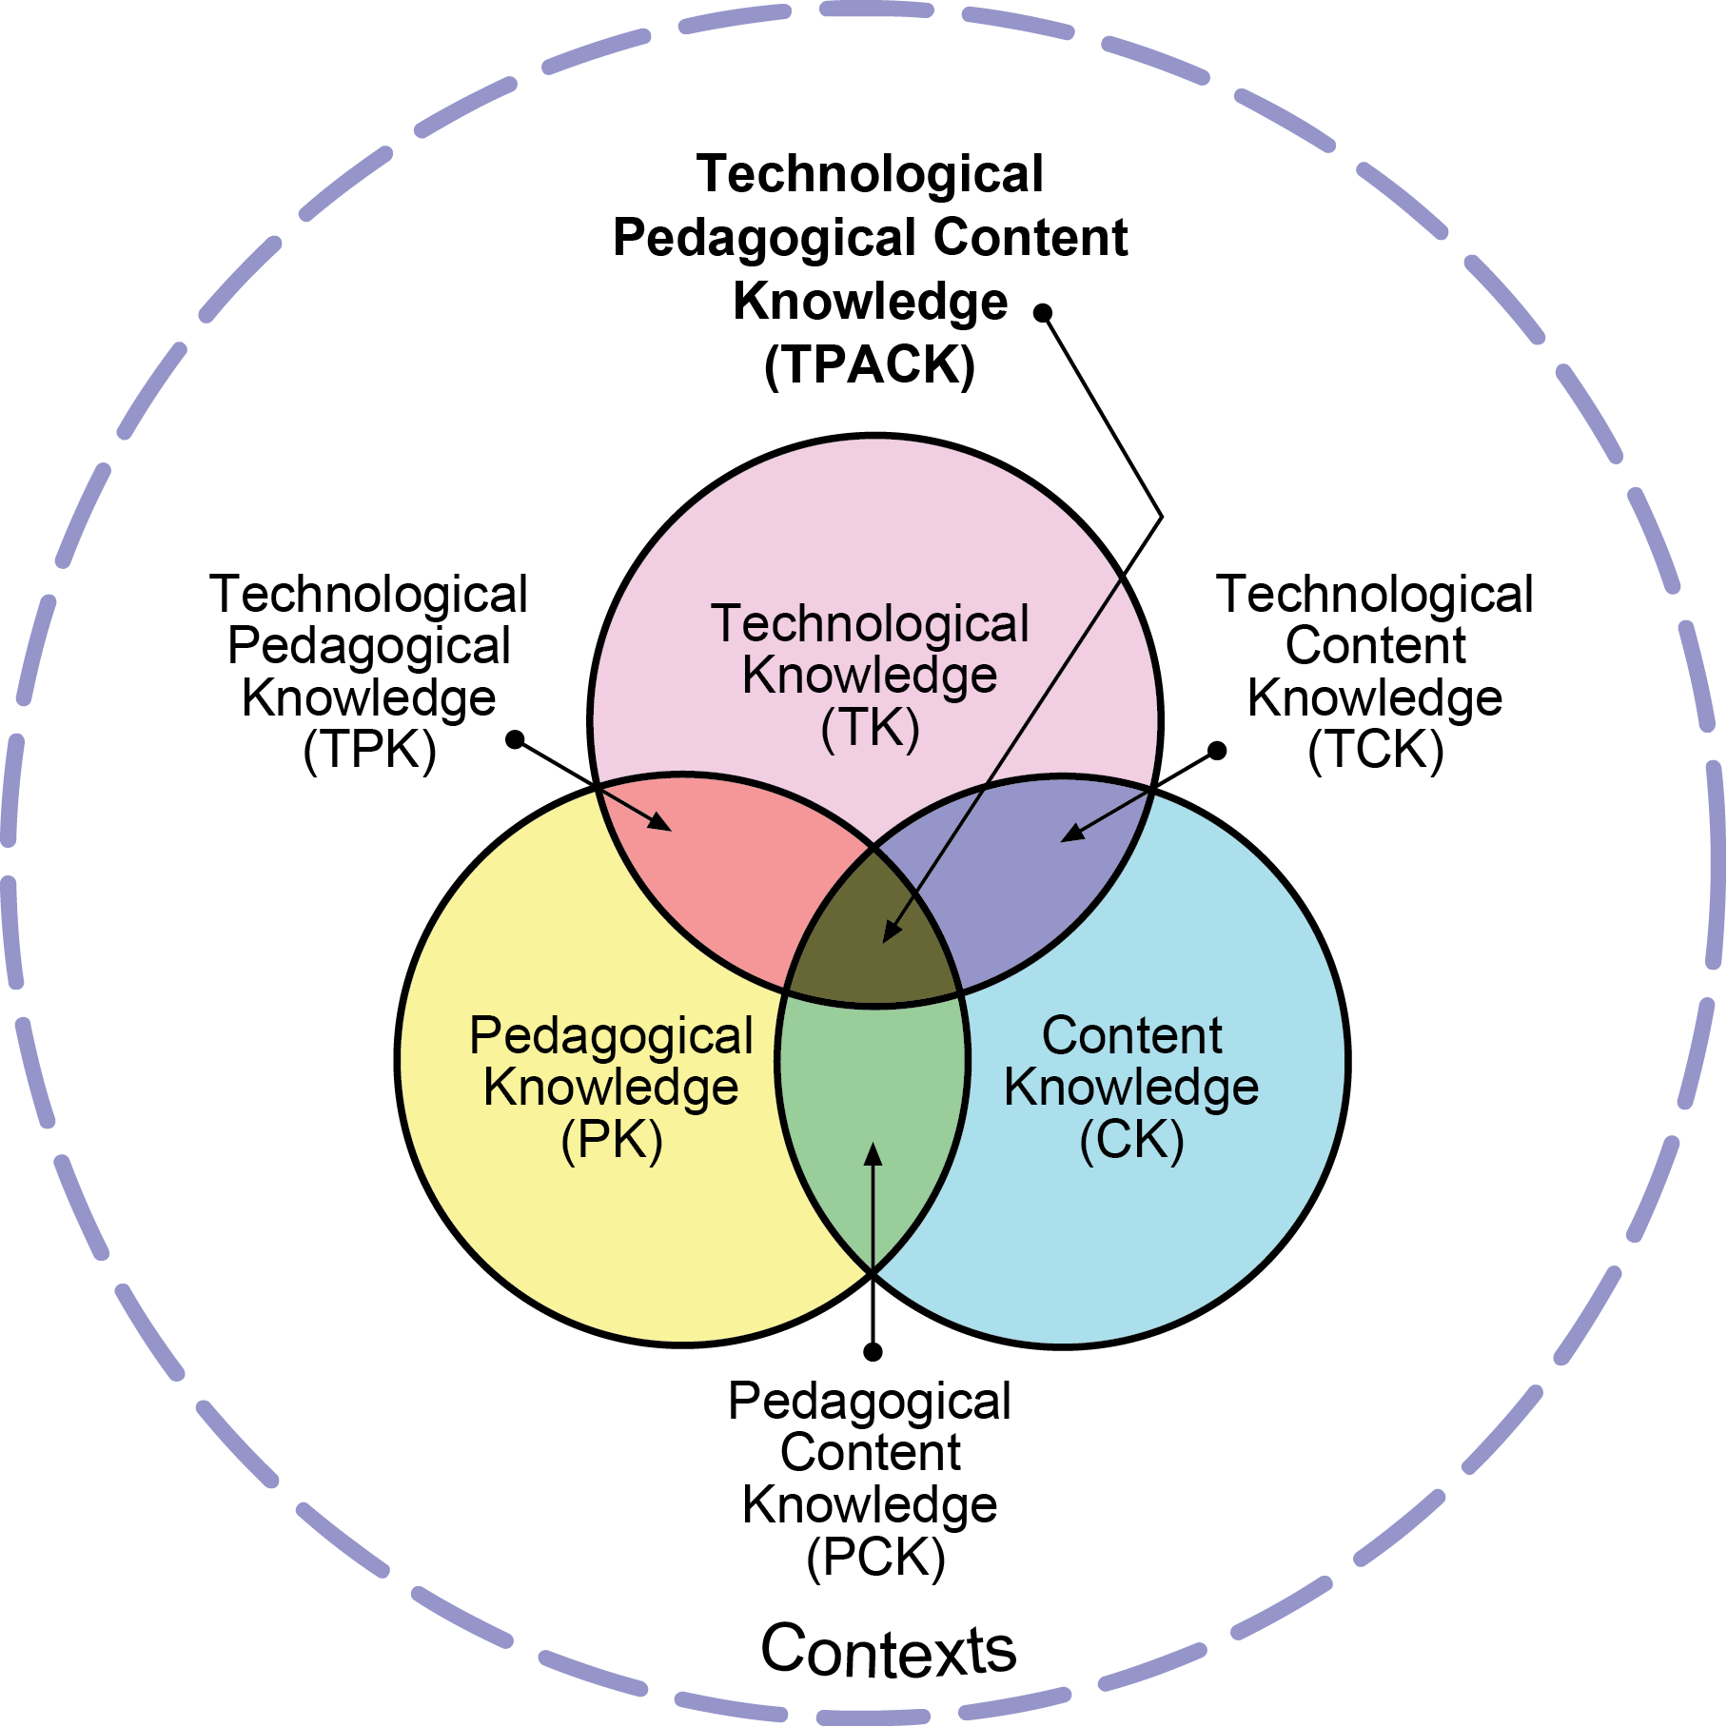

Figure 6: TPACK module [Source: http://tpack.org. Reproduced with permission of the publisher © 2012]

5.7 Self-assessment
Assessment | Tick the boxes to assess whether you have achieved the outcomes for this unit. If you cannot tick the boxes, you should go back and work through the relevant part in the unit again.  I am able to:  # Checklist  1 Describe the unique challenges associated with the use of classroom technology.  2 Identify and discuss how effective higher technology such as projectors, computers, multimedia and the internet enhance effectiveness in teaching.  3 Discuss the benefit of multimedia in technology-based instruction.  4 Identify the challenges encounter by teacher educators when using distance learning technology.

5.8 Selected references
Key references and useful further reading includes:
Dike, H. (2008) Educational Technology, Capiic publishers
University of Port Harcourt, Nigeria.
Gahala M. (2001) critical issues: Promoting Technology, available at /www.educationmit.edu/paper/games0CNet-eduAroade.pdf
Nwoji, J.(2013) Production and Utilization of teaching materials.
Fulladu Publishing company Enugu, Ngeria.
Thomas, E. , David B. , Rick, F. , & Virginia A. (2004) using multimedia in classroom Presentation: Best principles (http://www.teachpsych.org/resources/document/otrp/Pedagogy/classroommultimedia.pdf)
http://www.ncrel.org/sdrs/area/issues/method/tecnlgy/te101k13htm
Edu techwikipedia http://en.wikipedia.org/wiki/Educational technology.
www.itdl.org/journal/Aug10/article01.htm

Glossary
Blogging - Abbreviated version of ‘weblog’, a term used to describe websites that maintain on going chronical of information.
Classroom needs: Things that must be provided in the class for Learner to succeed.
Classroom size: Total number of Students in a particular Class.
Small class size: Class size consisting of 20 to 40 students.
Large class size: Class size consisting of 150 to 200 students.
Contiguity Principle: Arrangement or keeping text close to its corresponding graphics on a screen to facilitate learning.
Creative Common Licence- Licensing framework which provides legal mechanisms to ensure that authors of materials can retain acknowledgement while allowing it to be shared.
Data visualization-- is the graphical representation of information to find hidden trends and correlations that can lead to important discoveries.
Digital storytelling-- involves combining narrative with digital content to create a short movie or presentation.
Disability: A condition of being unable to do things in the normal way.
e-learning – learning mediated through the use of digital resources.
Google jockeying-- involves a participant in a class surfing the Internet during the class for terms, ideas, websites, or resources mentioned by the presenter.
Grid computing, which uses middleware to coordinate disparate IT resources across a network, allowing them to function as a virtual whole, providing remote access to IT assets and aggregating processing power.
Hypermedia: Multimedia system that include nonlinear structure of information units, events, and discrete media. It is one of the multimedia applications.
Instant messaging (IM) – IM is a form of online communication that allows real-time interaction through computers or mobile devices.
Instructional Design: Is the practice of creating instructional experience which make the acquisition of knowledge and skills more effective and appealing.
Mashups, -- are web applications that combine data from more than one source into a single integrated tool.
Modality principle: Concerned with the type or mode of media presentation for various type of content using audio instead of written words in order to obtain significant gains in learning.
Multigrade classroom: Classroom where single Teacher facilitates two or more adjacent grade levels for the most of the day
Multimedia: Is a concept that has to do with putting two or more media together to form a single medium of instruction.
Multimedia Principle: Implies that words that are supported by pictures enhance learning more than words alone.
OER (Open Educational Resources) – Any resources that openly available for use without any accompanying need to pay royalties or licence fees.
Online applications – these are web-based programmes that run in web browsers and typically replicate the functionality currently available on desktop-based applications.
Open journaling--- manages the process of publishing peer-reviewed journals online, allowing authors to track submissions through the review process, which creates a sense of openness and transparency uncommon in traditional, peer-reviewed publications.
Physically challenged: To have a physical or mental problem that makes it difficult to do things as easily as other people.
Podcasting – ‘podcasting’ refers to any combination of hardware, software, and connectivity that permits automatic download of (usually free) audio and video files to a computer, smart phone, or MP3/MP4 player to be listened to or watched at the user’s convenience.
Redundancy Principle: Stressed avoiding having text and narration together when the narration simply reads back the exact same text showing on screen.
Regular classroom: Classroom with normal or ordinary condition.

RSS – Real Simple Syndication (RSS) is a protocol that allows users to subscribe to online content by creating lists of preferred sources of information in a ‘reader’ or ‘aggregator’ that automatically retrieves content updates, saving users time and effort.
Slideware: Any PowerPoint or similar presentation.
Social Network Sites – Web-based services that allow people to construct a public or semi public profile without a bound system.
Virtual Worlds – virtual worlds are immersive online environments whose ‘residents’ are avatars representing individuals who participate via the Internet.
Wikis – a wiki enables documents to be written collaboratively, in a simple mark-up language using a web browser.

